**DEPARTMENT OF MECHANICAL ENGINEERING  
  
Subject: Fundamentals of Programming  
Lab MANUAL: 9  
Submitted by: M.Ahmad Raza  
Registration number: 467253**

**Semester No. 1  
Date: December 7, 2023**

**FIRST TASK**

#include <iostream>

using namespace std;

int main() {

const int size = 3;

int matrix[size][size];

cout<<"Enter the elements of the 3x3 matrix:"<<endl;

for(int i=0;i<size;++i){

for(int j=0;j<size;++j){

cout<<"Enter element at position "<<i+1<<","<<j+1<<":";

cin>>matrix[i][j];

}

}

cout<<"\nThe entered matrix is:"<<endl;

for (int i=0;i<size;++i){

for (int j=0;j<size;++j){

cout<<matrix[i][j]<<" ";

}

cout<<endl;

}

int leftDiagonalSum = 0;

for (int i = 0; i < size; ++i) {

leftDiagonalSum += matrix[i][i];

}

cout<<"\nThe sum of the left diagonal is: "<<leftDiagonalSum<<endl;

int rightDiagonalSum = 0;

for (int i=0;i<size;++i) {

rightDiagonalSum+=matrix[i][size-1-i];

}

cout<<"The sum of the right diagonal is: "<<rightDiagonalSum<<endl;

return 0;

}

**SECOND TASK**

#include <iostream>

using namespace std;

const int size = 3;

void addMatrices(int matrix1[size][size], int matrix2[size][size], int result[size][size]) {

for (int i = 0; i < size; ++i) {

for (int j = 0; j < size; ++j) {

result[i][j] = matrix1[i][j] + matrix2[i][j];

}

}

}

int main() {

int matrix1[size][size];

int matrix2[size][size];

int result[size][size];

cout<<"Enter the elements of the first 3x3 matrix:"<<endl;

for (int i=0;i<size;++i){

for (int j=0;j<size;++j){

cout<<"Enter element at position "<<i+1<<","<<j+1<<":";

cin>>matrix1[i][j];

}

}

cout<<"\nEnter the elements of the second 3x3 matrix:"<<endl;

for (int i=0;i<size;++i) {

for (int j=0;j<size;++j){

cout<<"Enter element at position "<<i+1<<","<< j+1<<":";

cin>>matrix2[i][j];

}

}

addMatrices(matrix1, matrix2, result);

cout<<"\nThe sum of the matrices is:"<<endl;

for (int i=0;i<size;++i){

for (int j=0;j<size;++j){

cout<<result[i][j]<<" ";

}

cout<<endl;

}

return 0;

}

**THIRD TASK**

#include <iostream>

using namespace std;

const int size = 3;

void transposeMatrix(int matrix[size][size], int result[size][size]) {

for (int i = 0; i < size; ++i) {

for (int j = 0; j < size; ++j) {

result[j][i] = matrix[i][j];

}

}

}

int main() {

int matrix[size][size];

int transposedMatrix[size][size];

cout << "Enter the elements of the 3x3 matrix:" << endl;

for (int i = 0; i < size; ++i) {

for (int j = 0; j < size; ++j) {

cout << "Enter element at position " << i + 1 << "," << j + 1 << ": ";

cin >> matrix[i][j];

}

}

transposeMatrix(matrix, transposedMatrix);

cout << "\nThe original matrix is:" << endl;

for (int i = 0; i < size; ++i) {

for (int j = 0; j < size; ++j) {

cout << matrix[i][j] << " ";

}

cout << endl;

}

cout << "\nThe transposed matrix is:" << endl;

for (int i = 0; i < size; ++i) {

for (int j = 0; j < size; ++j) {

cout << transposedMatrix[i][j] << " ";

}

cout << endl;

}

return 0;

}

**Fourth TASK**

#include <iostream>

using namespace std;

const int size = 3;

void multiplyMatrices(int mat1[size][size], int mat2[size][size], int result[size][size]) {

for (int i=0;i<size;++i) {

for (int j=0;j<size;++j){

result[i][j] = 0;

for (int k=0;k<size;++k) {

result[i][j] += mat1[i][k] * mat2[k][j];

}

}

}

}

void displayMatrix(const char* matrixName, int mat[size][size]) {

cout<<matrixName << " matrix:" <<endl;

for (int i=0;i<size;++i) {

for (int j=0;j<size;++j){

cout<<mat[i][j]<< " ";

}

cout<<endl;

}

}

int main() {

int matrix1[size][size];

int matrix2[size][size];

int resultMatrix[size][size];

cout << "Enter the elements of the first 3x3 matrix:"<<endl;

for (int i=0; i<size;++i) {

for (int j=0;j<size;++j) {

cout<<"Enter element at position " << i+1<<","<<j+1<<":";

cin>>matrix1[i][j];

}

}

cout<<"Enter the elements of the second 3x3 matrix:"<<endl;

for (int i=0;i<size;++i){

for (int j=0;j<size;++j){

cout << "Enter element at position " << i + 1 << "," << j + 1 << ": ";

cin>>matrix2[i][j];

}

}

displayMatrix("Matrix1", matrix1);

cout<<endl;

displayMatrix("Matrix2", matrix2);

cout<<endl;

multiplyMatrices(matrix1, matrix2, resultMatrix);

displayMatrix("Result", resultMatrix);

return 0;

}

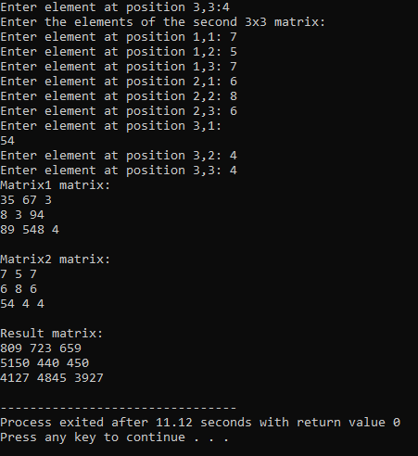

**Fifth TASK**

#include <iostream>

using namespace std;

void printMultiplicationTable(int number, int multiplier) {

if (multiplier <= 10) {

cout<<number<<" x "<<multiplier<<" = "<<number*multiplier<<endl;

printMultiplicationTable(number, multiplier + 1);

}

}

int main() {

int number;

cout<<"Enter the number to print its multiplication table: ";

cin>>number;

cout<<"Multiplication Table of "<<number<<":"<<endl;

printMultiplicationTable(number, 1);

return 0;

}

